**Q1:**

a)

EU(MM) = 0.8*(-9) + 0.2*(-11) = -9.4

EU(SM) = 0.8*(-11) + 0.2*(-7) = -10.2

EU(Both) = 0.8*(-15) + 0.2*(-12) = -14.4

Since the expected cost of MM is the lowest, the company would choose MM.

b)

If the oracle says the economy will be Good, the company will choose MM as it has the least cost in a good economy. If the oracle says the economy will be Bad, the company will choose SM as it has the least cost in a bad economy.

E(cost) = 0.8*9 + 0.2*7 = 8.6

The expected minimum cost will be $8.6 thousand.

c)

Let the cost of the oracle be C.

Total cost using oracle = C + 8.6

Total cost without oracle = 9.4

The company will choose to use the oracle if the total cost using the oracle is less than the total cost without the oracle.

C + 8.6 < 9.4

C < 0.8

Hence, DecisionMakers should pay less than $0.8 thousand to the oracle.

**Q2:**

a)

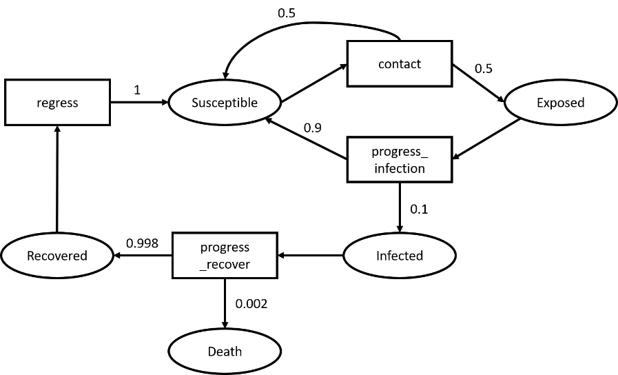

b)

The problem was modelled as an MDP. This is because outcomes in the problem are stochastic and can be represented by transitions and their associated probabilities.

However, the problem states that half of recovered individuals may experience long-term effects. This could affect future probabilities. For example, if the long-term effect causes them to be more sickly, future infections could increase their chance of mortality. This violates the assumption that the transition probabilities are affected only by the current state and the not the history of previous states. Hence, the transitions are non-Markovian in nature.

**Q3:**

a)

UUCB for A = $U\left(A\right)+c\sqrt{\frac{ln⁡(N\left(A\right)+N(B))}{N(A)}}$ = $\frac{4}{8}+ 1*\sqrt{\frac{ln⁡(32)}{8}}$ = 1.15819

b)

UUCB for B = $U\left(B\right)+c\sqrt{\frac{ln⁡(N\left(A\right)+N(B))}{N(B)}}$ = $\frac{10}{24}+1*\sqrt{\frac{ln⁡(32)}{24}}$ = 0.79667